GEOG 5060 – GIS and the Environment - Assignment Three
An Investigation into Resolution Effects Using Geomorphometrics.

Introduction
Geomatics is the modern scientific term referring to the integrated approach of measurement, analysis, and management of the descriptions and locations of Earth-based data, often termed spatial data. (University of Florida, 2007), to produce geographical information for scientific, administrative and technical endeavours (Cusimano et al. 2007). It encompasses a broad range of disciplines that can be brought together to create a detailed but understandable picture of the physical world and our place in it. These disciplines include:
- surveying
- mapping
- remote sensing
- geographic information systems (GIS)
- global positioning system (GPS) (NRC 2007).
These data are processed and manipulated with state-of-the-art information technology (University of Florida, 2007). Geomatics has applications in all disciplines which depend on spatial data, including forestry, environmental studies, planning, engineering, navigation, geology and geophysics. It is thus fundamental to all areas of study which use spatially related data, as the ones listed above ( University of Florida, 2007).
Within geomatics the measures of the state and change in surface geometry of the Earth's physical horizons (geomorphometrics) (Turner 2007) play an important roll. Measurement and characterization of terrain have interested scientist of various disciplines within earth’s sciences for more than hundred years (Cayley, 1859); this interest gave rise to the creation of the discipline called geomorphometry first announced by Chorley (1957). Traditionally the information needed for the application of morphometric methods, was extracted manually from the topographic sheets, work which was obviously very laborious and time consuming. Currently, the availability of digital information has led to analysis made much faster and easier compare to traditional methods (Vega, 2000a, 2000b).
As traditional methods had problems current methods also do. Thresholds appear when deciding which method to use for deriving geomorphometrics, and more over questions like: What are the effects of shape and size of the region on the metric? At what resolutions are the measures to be taken? (Turner 2007), among many others, arise when working on this topic. What is clear is that a lot of research has to be done in order to understand what and how the models are affected by different variables and how to correct for these effects. Besides this, it is to remember that any method will have pros and cons and is for the scientist to decide, based on the situation and desired application of the information to be produced, which one to use (Felicísimo 1998).
Deriving slope from DEM´s using different methods is a good example of these thresholds. The slope of a point in the terrain is defined as the normal vector of the surface of that point and the vertical and it can be calculated using the following expression (Wood 1996., Felicísimo 1998):
γ = tg -1 √a10
This expression is the most commonly used, though, various alternatives exist to calculate slope and, as mentioned before, each has its pros and cons which most to be evaluated when used. The most widespread existing methods are classified upon the number of points/cells utilized for the calculation: 2, 3, 4 and 8. Algorithms based on 2 and 3 cells are reported to have as advantage the non introduction of smoothness in the data (Felicísimo 1998), though, in our study we will see how, regarding our aim, smoothness is actually good at some extend. Literature suggests also to prefer 8 cell algorithms to 4 cells ones since they are less sensitive to DEM errors (Felicísimo 1998); again, in our results we will exemplify how choosing from one or another method depends on the aim to be achieved.

Aims
The aim of this study is to demonstrate how the resolution of a DEM can affect the accuracy of visual representations of slopyness.

Our objectives will be to show the effect of resolution of a DEM on the quality of visual representation of ‘slopyness’, and also to provide a number of good examples using a range of resolutions which will be easily interpreted and understood by students for use in future teaching. Further to this we aim to identify and provide a high enough resolution DEM that provides an accurate, high quality 3D picture of slopyness.

Apparatus
Java1.5 compiler & Runtime environment
ProcessorDEMruns.java
Woldsdem.asc
Arc Scene
Arc Map

Method
We followed instructions provided and amended the ProcessorDEMruns.java file to incorporate the correct folder where our files were placed. We also amended the script as we were using the woldsdem file rather than the catchment file provided.
We compiled and ran the java script to output a number of maps using 2,4,8 and 16 cells to generate the slopyness of the wolds area.
Using Arc Scene, we then overlaid each slopyness output map onto the original wolds DEM to determine the level of agreement between the height on the DEM and the slopyness predicted by the java script. To generate an accurate visual representation of height in ArcScene, we set the z factor to 3 to emphasise the degree of slopyness.
We generated a ‘fly-through’ in ArcScene to investigate the compatibility between the slopyness output and the elevation given by the original DEM.
After comparing outputs in ArcScene we identified the most accurate output and recorded the ‘fly-through’.

Results
Due to disk space limitations, we were unable to output maps using 16 cells as they required more disk space than was available. Figures shown below therefore only include examples where outputs have been calculated using 2,4 and 8 cell neighbourhoods.
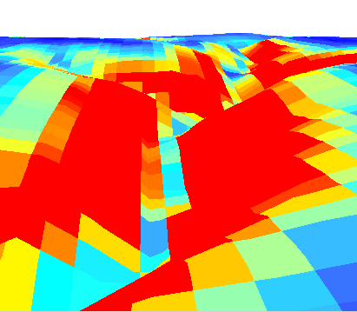

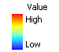

Figure 1. 3D representation of the output of slopyness using 2 cells overlaid onto the original Wolds area DEM, as viewed in Arc Scene.
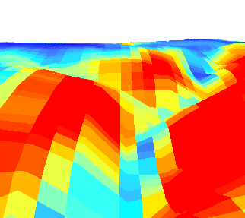

Figure 2. 3D representation of the output of slopyness using 4 cells overlaid onto the original Wolds area DEM, as viewed in Arc Scene.
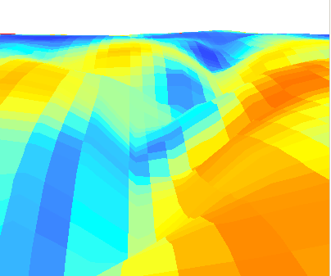

Figure 3. 3D representation of the output of slopyness using 8 cells overlaid onto the original Wolds area DEM, as viewed in Arc Scene.

Figure 4. Slide showing the difference between outputs of slopyness, for use in future training purposes.

Discussion
The main finding of this study was that the accuracy of the ‘slopyness’ map outputted by the java script varied depending on the number of cells used in the calculation.

As our results show, the output using 4 cells, (figure 2) provided the best example of slopyness when compared to the original Wolds area DEM. During the analysis we found that this output correlated best with the height obtained from the Wolds area DEM allowing for the most accurate representation of slopyness in the 3D environment.

The output using 8 cells (figure 3) seemed to provide too smooth a surface creating blurred edges and ill-defined values of slopyness. There were also a large number of areas with high slopyness on the output that did not correlate with height and slope on the Wolds area DEM causing a high level of incongruence between the data sets. This appears to have been due to the averaging of too large an area of data which resulted in a loss of detail at low spatial scale.

The output using 2 cells (figure 1) appeared to not provide a smooth enough visual representation of slopyness. It seems that using only 2 cells did not include enough data with which to accurately predict the slope. This surface appeared rough showing a high ‘blockiness’ of data in the visual representation. Areas of slopyness did also not seem to correlate that well with the original DEM dataset.

The fly-through recorded in Arc Scene (on the included file) provided good visual representation of this that could be used in future teaching exercises. We found that the fly-through aided our interpretation of the data making it easier to visualise and understand its potential for use in a 3D landscape.

References
Cusimano, M., Chipman, M., Glazier, R., Rinner, C. & Marshall, S. (2007). Geomatics in injury prevention: the science, the potential and the limitations. Injury Prevention. 13 (1): 51-56
Cayley, A. (1859). On contour and slope lines, The London, Edinburgh, and Dublin Philosophical Magazine and Journal of Science. XVIII, pp. 264-268. [cited by Felicísimo, 1998]
Chorley, R., Malm, D. & Pogorzelski, H.(1957) A new standard for estimating drainage basin shape, American Journal of Science, 255(2) pp.138-141.[cited by Felicísimo, 1998]
Felicísimo, A. (1998). Modelos Digitales del Terreno. Curso Introductorio. [on line] [accessed 5 May 2007] Available from: http://www.etsimo.uniovi.es/~feli/CursoMDT/Tema_4.pdf
Natural Resouces Canada (NRC). Geomatics Canada. (2007). [on line] [accessed 20 april 2007] Available from: http://ess.nrcan.gc.ca/geocan/about_e.php
Turner, A. (2007). Geomorphometrics. [on line] [accessed 1 May 2007] Available from: http://www.geog.leeds.ac.uk/people/a.turner/research/interests/geomorphometrics/
University of Florida. Geomatics. (2007). [on line] [accessed 25 april 2007] Available from: http://www.surv.ufl.edu/
Vega, M., Zubiaur, K. & González, Y. (2000a). Empleo del modelo digital del terreno para el estudio morfométrico de la Sierra de los Organos. En CD 5to. Taller Internacional Informática y Geociencias, Ciudad Habana, Memorias marzo del 2000. ISNN 1028-8961
Vega, M., González K., Zubiaur, & Gil, J. (2000b): Utilidad del empleo de datos digitales del relieve y el drenaje de una región para estudios geológicos. Aplicación en la Sierra de los Organos. En CD II Congreso Internacional de Geomática, Ciudad Habana, Memorias mayo del 2000, ISBN 959-7160-01-3.
Wood, J. (1996). The geomorphological characterisation of digital elevation models Unpublished PhD thesis, Department of Geography, University of Leicester [on line] [accessed 5 May 2007] Available from:http://www.soi.city.ac.uk/~jwo/phd

